✴

# Document an existing experience

**TIP**

As you add steps to the experience, move each these “Five Es” the left or right depending on the scenario you are documenting.

Narrow your focus to a specific scenario or process within an existing product or service. In the **Steps** row, document the step-by-step process someone typically experiences, then add detail to each of the other rows.

Customer experience journey map

Use this framework to better understand customer needs, motivations, and obstacles by illustrating a key scenario or process from start to finish.

When possible, use this map to document and summarize interviews and observations with real people rather than relying on your hunches or assumptions.

Created in partnership with

**SCENARIO**

Navigating through a forest detection app and understanding its functioning

**Steps**

**Browsing, booking, attending, and rating a local city tour**

What does the person (or group) typically experience?

## Interactions

What interactions do they have at each step along the way?

**People:** Who do they see or talk to?

**Places:** Where are they?

**Things:** What digital touchpoints or physical objects would they use?

# Entice

How does someone initially become aware of this process?

After analyzing the images, the range of spread is to be determined.

**Identification of fire spread area**

Evacuation from the area

**How to detect forest fire?**

**How does forest fire occur?**

How do they monitor and predict it so as to mitigate damage?

Is it possible to identify the source?

They can interact with the people near the forest to inform them about it

Forest is the place but the people using it can be anywhere

They can also interact with the forest department officials and fire services

The images are taken via drones since they can cover large areas. So they are the digital touchpoints

# Enter

What do people experience as they begin the process?

Based on the Fire's spread range, the measures to stop the fire should be decided and played

**How to use this application?**

**How does the application work?**

How do I use this app? Is there a tutorial to learn?

By which process does it find the forest fire?

Continuous System interaction for disaster analysis

Interact with video frame camera for collecting images.

# Engage

In the core moments in the process, what happens?

By which process does it find the forest fire?

**How does the application work?**

**How to reduce forest fire?**

**Image processing**

**Deep Learning**

**Location Sharing**

Capturing the images continuously for processing to know about the Fire

Captured images get processed and analyzed using various deep learning algorithms to find the fire

A GPS tracker should be implanted with the drone camera system which would send the exact location of the Fire to the Fire Station

Conversations and planning with on duty Ofcials

Location of the forest fre area is send to the ofcers(eg,. to the fre service man)

# Exit

What do people typically experience

as the process finishes?

**Implementation of strategies to mitigate damge and evacuate people**

Extent of disaster effects and determining recovery

Notifcation of fre clears

After identifying the impact, appropriate strategy is to be present to reduce impact

Contact helpline in case of forest fre detection.

Direct information to the people that the fre was fully cleared

Opinion and update related feedbacks.

# Extend

What happens after the experience is over?

They characterized a significant decrease in oxygen or fuel

Helping out if there are any victims and watching for helpline

Contacting near-by areas for additional help

Communicating with government officials for fast recovery

**Goals & motivations**

1

Improving in mitigation techniques

To make assure of immediate and timing prevention

Help me to safeguarding the trees and protect animal

Help me to protect the surrounding and environment

Detect the forest fire and extinguish it

Technological advancement and using it in right path

To ensure global safety and prevent loss of lives

Correct area and time prediction

Directing all the people to clear the fre

Providing message and

alert system to people.

Providing quick solution ,steps and ensure protected environment.

Help me by communicating the information to the humans

At each step, what is a person’s primary goal or motivation? (“Help me...” or “Help me avoid...”)

Many factors affect how a wildfire burns and how difficult it may be to control.

## Positive moments

Better facility to decrease the effect of damages

Forest lives saved from natural disaster

They are happy by safeguarding the surrounding environment

They would have a satisfaction of protecting

he environment

Finding the forest fre fastly

Training to work on self learning from patterns of occurence

People generally would be satisfed by their protecting job

Examining the overall performance and out[ut.

Designing website and alert mechanism.

Motivating by delivering successful risk management

What steps does a typical person find enjoyable, productive, fun, motivating, delightful, or exciting?

## Negative moments

cause lots of damages as ozone layer depletion, loss of livelihood for tribal people, destroys the nutrient rich top soil.

Polluting the air with emissions harmful to human health

Many factors affect how a wildfire burns and how difficult it may be to control.

Can't reach the destination fastly

Fear of error causing activities or system failure

Not available at time when needed.

Inefcient and unfaithful idea when less accuracy.

Sometimes the information is not passed correctly

Data collection may be time consuming

High Cost and long duration to implement

What steps does a typical person find frustrating, confusing, angering, costly, or time-consuming?

Fear of loses of life and property

False triggering can cause low low accuracy

[**Share template feedback**](https://muralco.typeform.com/to/CiqaHVat?typeform-source=app.mural.co)

## Areas of opportunity

How might we make each step better? What ideas do we have? What have others suggested?

By giving right informations to the nearby peoples to keep all flammable objects away from fire

Follow Forest Fire Prevention Tactics When Burning Rubbish and extinguishes it

By a graphical representation of the data related to a project.

How might we have helped the people to secure their life

Well developed systems with no FAULTS

Availability even damage occurs

Increasing more data collection and storage

To secure all the living organism

Timely and accurate response

Optimized technological approach towards AI patterns

Designing web sites and applications

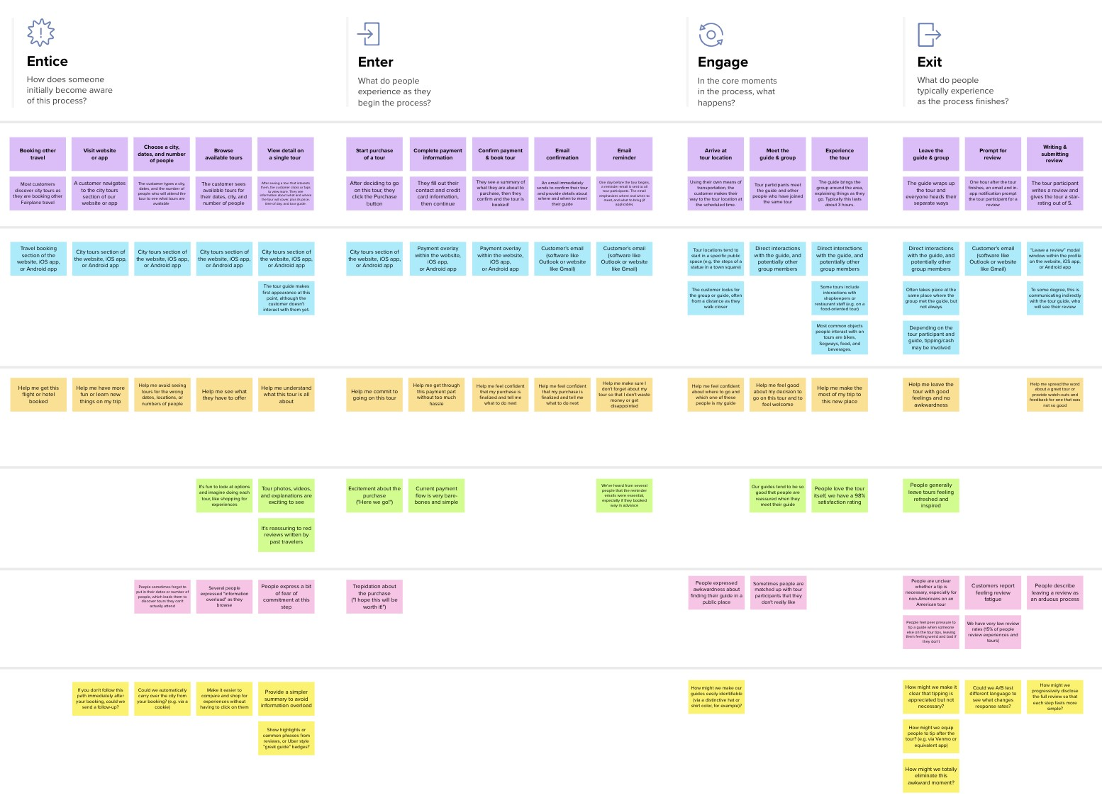

**Template**

**Need some inspiration?**

See a finished version of this template to kickstart your work.

[**Open example**](https://app.mural.co/template/f59f644b-b4b4-47b5-9ed6-3a8c71ceb612/896b31fe-5597-40ef-9b06-3811a1a45ace)